SR UNIVERSITY
LAB ASSIGNMENT-09

NAME:CHALLA.THANUSREE
HALL TICKET NUMBER:2403A54109
BATCH NO:04(DS)

Task Description#1 Basic Docstring Generation
Prompt:
Write a Python function that takes a list of integers and returns the sum of even and odd numbers separately as a tuple.
First, add a manual docstring using Google Style that clearly describes the function, its arguments, and return values.
Then, include a second version of the same function with a docstring generated by an AI tool.
I want to compare the manual docstring and the AI-generated one in terms of clarity and completeness.

Code:
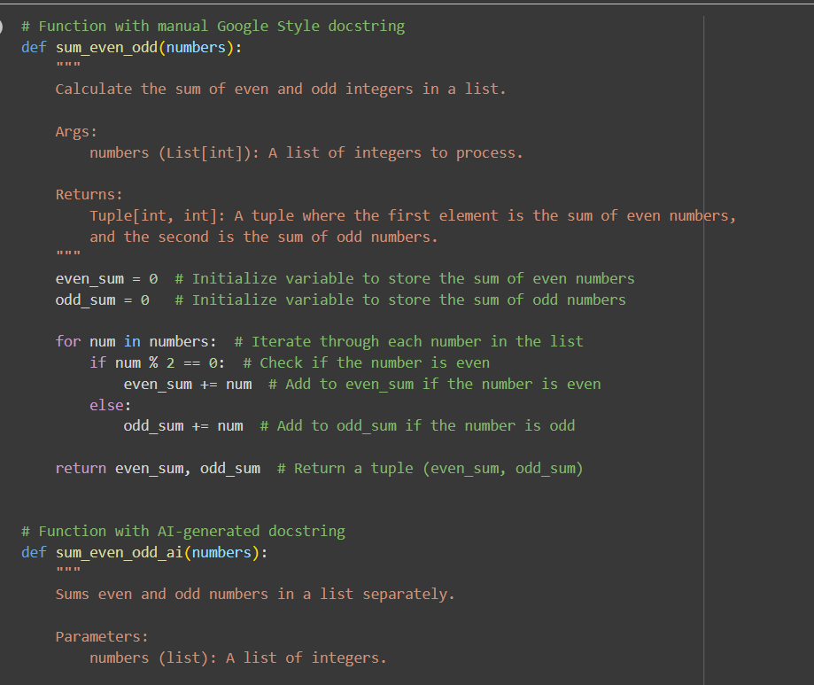
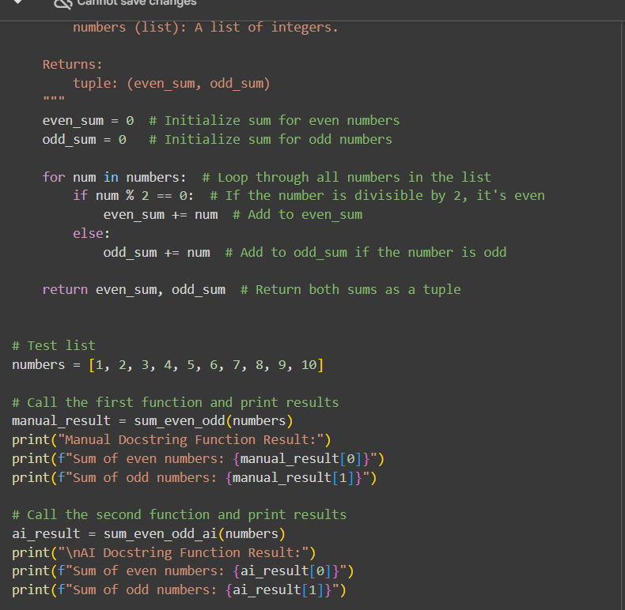
Output:

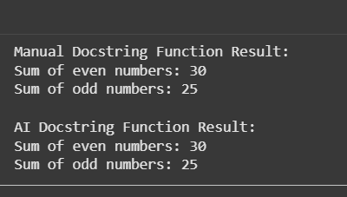
Explanation:
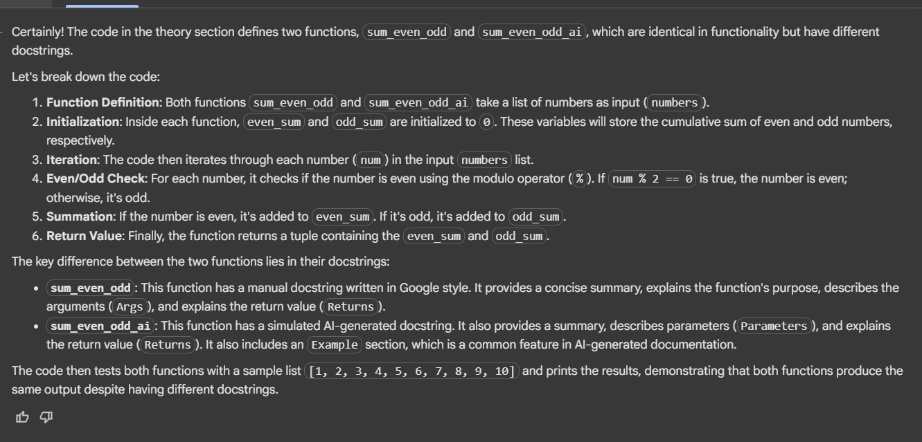

Expected Output#2: Students critically analyze AI-generated code comments.

Prompt:
Create a Python class called SRU_Student with attributes: name, roll_no, and hostel_status.
Add two methods:
- fee_update() to update or show fee status
- display_details() to show all student details
First, write manual inline comments for each line.
Then, use an AI tool to generate automatic inline comments.

Code:

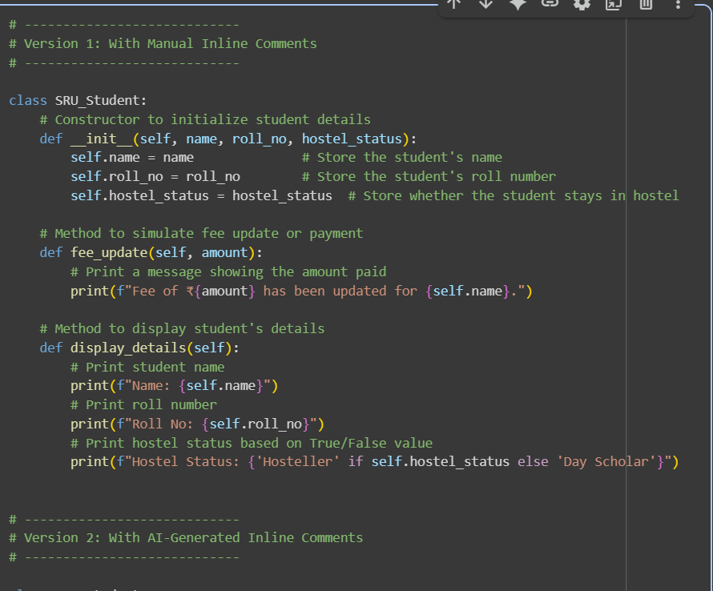
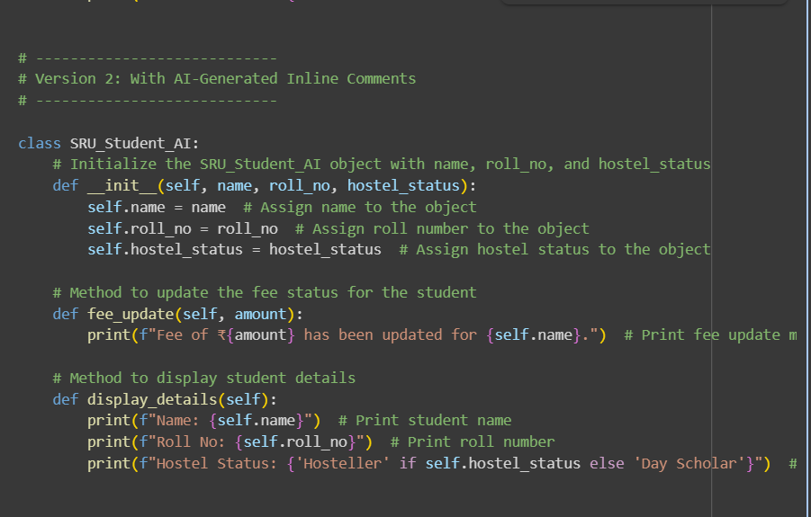
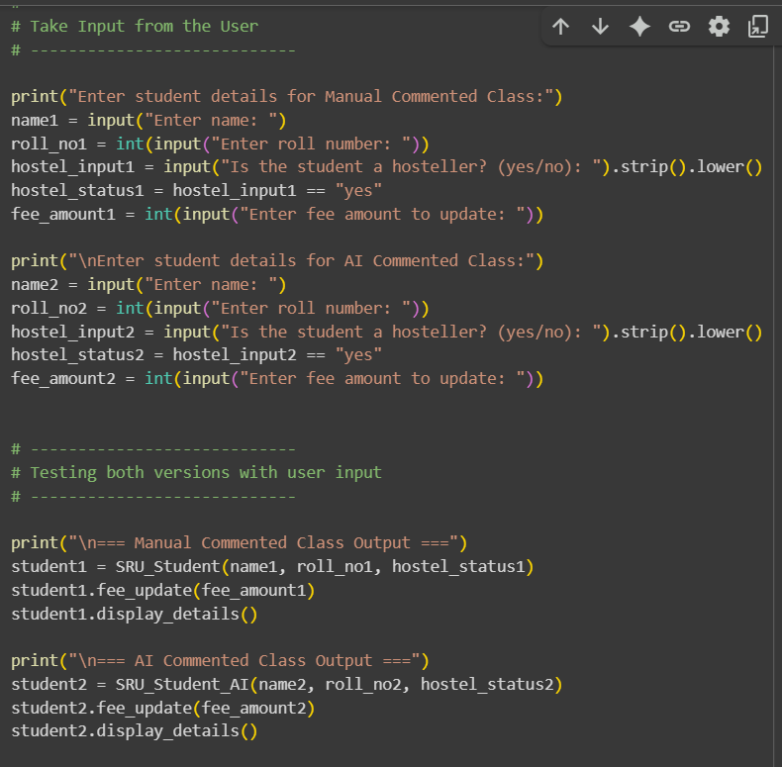
Output:
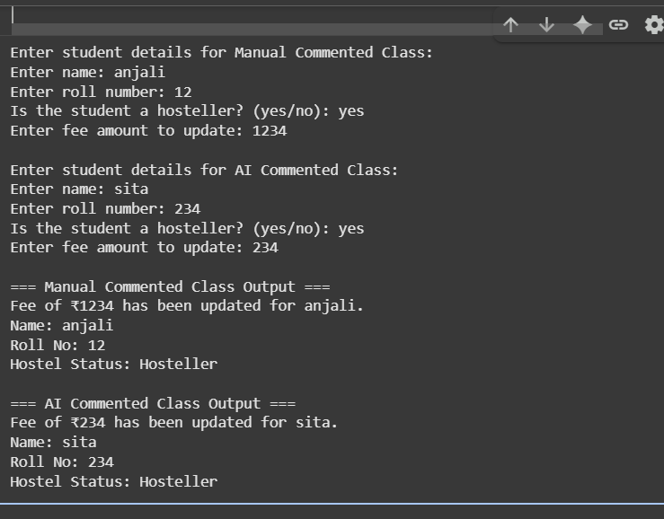
Explanation
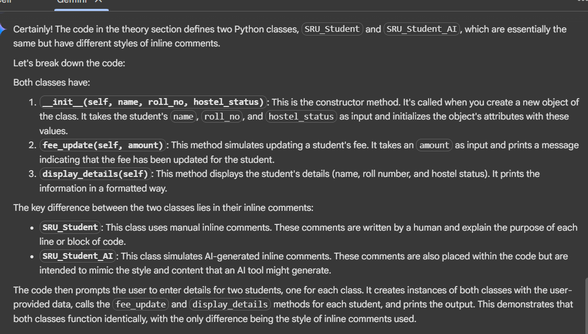

Task Description#3
Prompt:

Write a Python script with four functions: add, subtract, multiply, and divide.
Write manual docstrings for each function using NumPy style.
Then, use an AI tool to generate a module docstring and function docstrings.
Compare your manual docstrings with the AI-generated ones.

Code
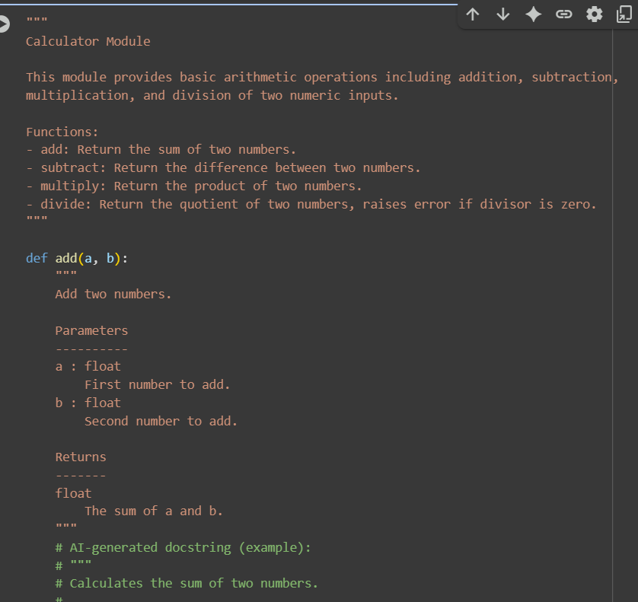
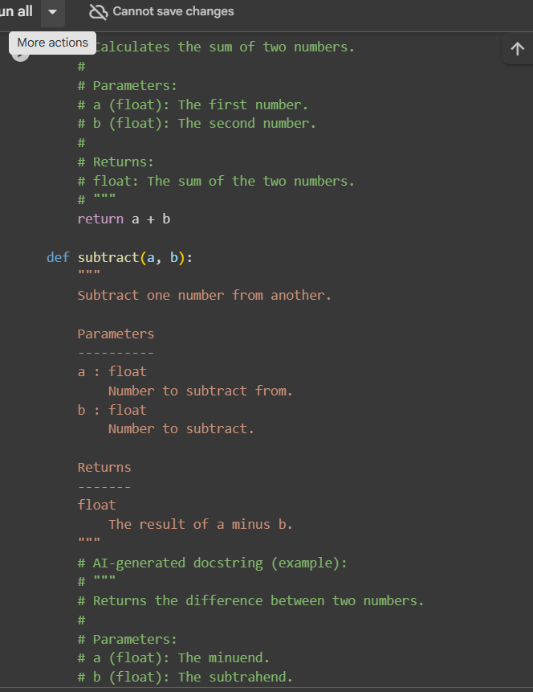
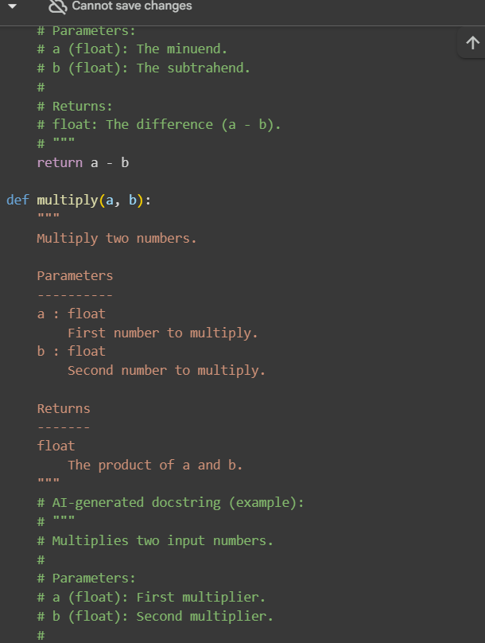
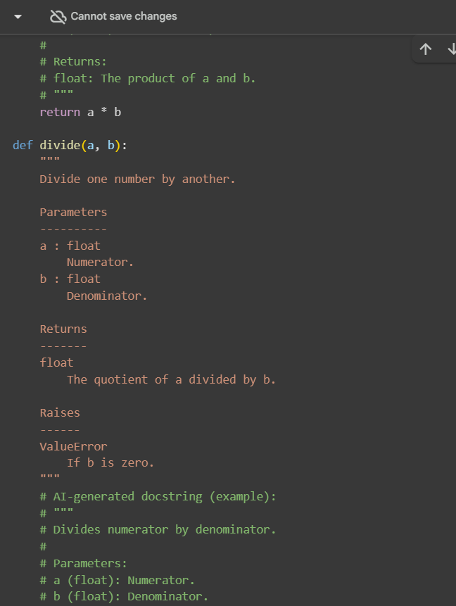
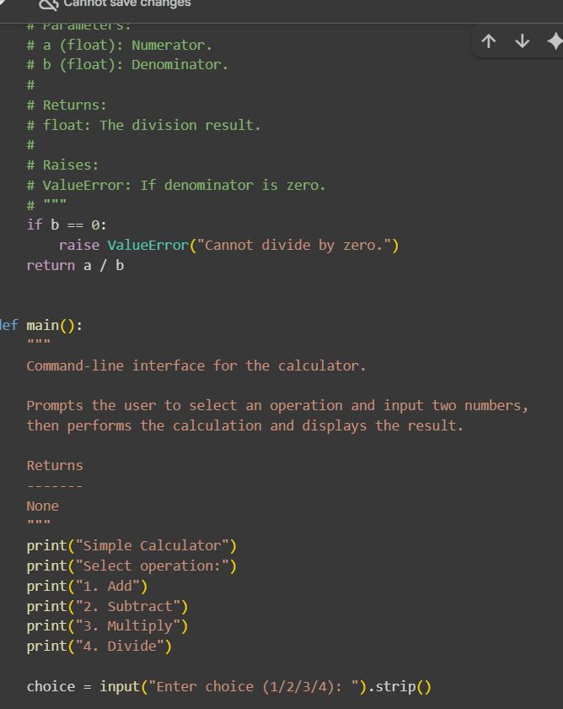
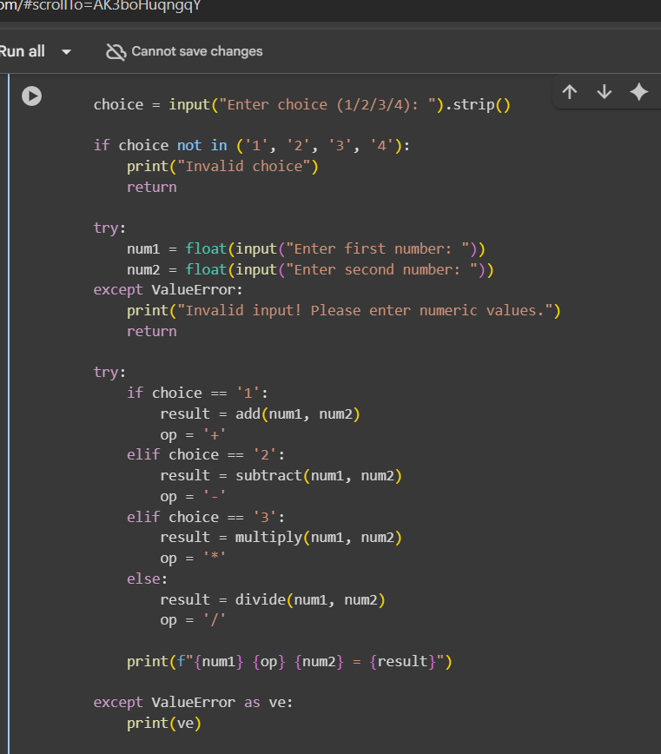
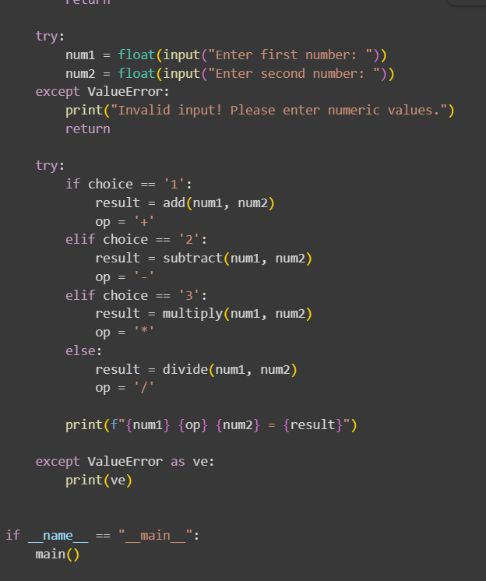

Output
